# **ABSTRACT**

This project deals with the design and testing of a graphene-based microstrip patch antenna for 5G applications. The antenna is made to work in the 28 to 32 GHz range, which is used in 5G millimetre wave communication systems. Normal microstrip patch antennas face problems at such high frequencies because they have narrow bandwidth and cannot change their frequency once designed. To solve this problem, graphene is used. Graphene has a special property where its surface conductivity can be changed by applying voltage. This allows the antenna to tune itself and work at multiple frequencies such as 28 GHz, 30 GHz, and 32 GHz, which are all part of the important 5G band.

The main goal of the project was to create a compact antenna with a 4 GHz bandwidth, to use graphene for reconfiguration, and to achieve a gain of more than 6 dBi. To achieve this, simulations were performed in MATLAB and CST Microwave Studio. These were used to optimise the antenna dimensions and graphene values. The results showed very good performance in terms of return loss, impedance matching, and frequency tuning. The antenna reached return loss values less than –10 dB for all target frequencies and showed a tuning range of 4.5 GHz.

One aim, however, was not fully achieved. The maximum gain was 4.27 dBi, which is lower than the target of 6 dBi. This was mainly because of graphene losses and substrate limits. Still, the design is promising for 5G systems as it is cost-effective, efficient, and does not need complex mechanical tuning. Future work will focus on increasing the gain and improving fabrication methods.

# **ABBREVIATIONS**

DC - Direct Current

5G- Fifth Generation

GHz - Gigahertz

IoT - Internet of Things

MPA - Microstrip Patch Antenna

Mm wave – Millimetre wave

RF - Radio Frequency

VSWR - Voltage Standing Wave Ratio

URLLC - Ultra-reliable low-latency communications

**TABLE OF CONTENTS**

**ACKNOWLEDGEMENT** 2

**ABSTRACT** 3

**ABBREVIATIONS** 4

**CHAPTER 1. INTRODUCTION** 7

**1.1** **Background and Motivation** 7

**1.2** **Aims and Objectives** 8

**1.3** **Scope** 9

**1.4** **Significance** 11

**CHAPTER 2. LITERATURE REVIEW** 12

**2.1 Comparison of Tunable Antenna Technologies** 13

**2.2 Graphene in Antenna Design** 14

**2.3 Research Gaps** 15

**2.4 Theoretical Framework** 16

**CHAPTER 3. METHODOLOGY** 19

**3.1 Research Techniques** 19

**3.2 Design Specifications** 20

**3.3 Substrate Selection** 21

**3.4 Patch Antenna Initial Design** 22

**3.5 CST Microwave Studio Simulation Workflow** 24

**3.6 Validation and Optimization** 26

**CHAPTER 4. RESULTS** 27

**4.1 Return Loss (S11) and Frequency Reconfiguration Performance** 27

**4.2 Surface Current Distribution** 28

**4.3 Radiation Pattern Characteristics** 29

**4.4 Comprehensive Performance Summary** 35

**4.5 Final Antenna Design** 36

**CHAPTER 5. DISCUSSION** 38

**5.1 Interpretation of Key Findings** 38

**5.2 Performance Evaluation Against Objectives** 38

**5.3 Comparative Analysis with Existing Literature** 39

**5.4 Limitations and Challenges** 40

**5.5 Recommendations for Future Work** 41

**CHAPTER 6. CONCLUSION** 43

**REFERENCES** 45

**LIST OF FIGURES**

**Figure 1. Return Loss(S11)** 27

**Figure 2. Surface Current Distribution at 28Ghz, 30Ghz and 32Ghz** 28

**Figure 3.Radiation Patterns (Far field directivity Phi=0)** 29

**Figure 4.Radiation Patterns (Far field directivity Phi=90)** 30

**Figure 5. Radiation Patterns (Far field directivity Theta=90)** 30

**Figure 6. 3D Radiation Pattern (a-c)** 33

**Figure 7. Gain** 34

**Figure 8. VSWR** 35

**Figure 9. Final Design of Microstrip Rectangular Patch Antenna** 37

# 

# **CHAPTER 1. INTRODUCTION**

## **Background and Motivation**

The dynamic progress of wireless communication systems has resulted in the widespread deployment of fifth-generation (5G) networks whose complexity is aimed at responding to the ongoing expanding demand that necessitates data rates, ultra-low latency, and high spectral efficiency. To meet these elastic needs, frequency bands in or around 24-40 GHz have been identified by millimeter wave (mm Wave), because of the wide available bandwidth. The 28-32 GHz band is instrumental to primary 5G uses, such as high-speed mobile broadband, the Internet of Things (IoT), and ultra-reliable low-latency communications (URLLC) [1].

The use of conventional microstrip patch antennas (MPAs) in mm Wave applications suffers from several critical limitations, although they are well suited to high-frequency applications. Their small bandwidth is one of the significant constraints that limit the flexibility of such an antenna to flexible spectrum utilization in contemporary communication systems. In addition, traditional MPAs are fixed-frequency and do not reflect the current requirements of multi-band and reconfigurable communication systems, as required in a next-generation network. Also, mm Wave frequencies are characterized by greater path loss and signal attenuation, requiring higher-gain antenna designs to ensure communication on significant frequencies [2].

To address these issues, reconfigurable antennas have become a potential remedy. Although conventional means of antenna tuning, including PIN diodes and varactors, provide frequency flexibility, they add considerable complexity to the biasing circuitry and fabrication cost. They may require additional elements, such as air gaps or mechanical adjustments, to reconfigure frequency. A more effective option is Graphene, which is a two-dimensional carbon material with excellent electronic characteristics. Direct reconfiguration of frequencies is possible thanks to the graphene voltage-tunable surface conductivity. This feature enables the electrical path length of the antenna to be dynamically varied by applying a bias voltage to provide operation at multiple discrete frequencies- e.g., 28GHz, 30GHz, and 32GHz- within a standard compact structure. This method has obvious advantages over the traditional ones, with the ability to improve the antenna's performance and get a smaller, less complicated process.

## **Aims and Objectives**

This project is about designing and testing a graphene-based microstrip patch antenna that can change its frequency. The antenna is made to work in the 28 to 32 GHz range, which is important for 5G technology. The main purpose of the project is to solve the problems that normal microstrip patch antennas face when used at millimeter wave frequencies. Ordinary antennas at this range often have narrow bandwidth and cannot easily change frequency. By using the special property of graphene, which can be tuned with voltage, the antenna in this project is able to adjust its frequency in a smooth and flexible way. The main goals of the project are explained below.

1. Design a Compact MPA for 28–32 GHz with a 4 GHz Bandwidth
2. Develop a compact MPA that operates efficiently within the 28–32 GHz frequency range, ensuring it meets the bandwidth requirements of 5G standards.
3. Design the antenna to achieve a 4 GHz bandwidth, facilitating optimal performance across the targeted frequency range for diverse 5G applications.
4. Integrate Graphene Layers for Frequency Reconfiguration
5. Incorporate graphene layers within the radiating patch to enable dynamic frequency tuning.
6. Graphene's voltage-tunable surface conductivity achieves three distinct frequency states: 28 GHz, 30 GHz, and 32 GHz. The frequency reconfiguration will be controlled by modulating the DC bias voltage, offering a versatile solution for adaptive communication systems.
7. Optimize Antenna Performance
8. Achieve a gain of greater than 6 dBi to ensure improved signal coverage and enhanced communication reliability at mm Wave frequencies.
9. Ensure a return loss (S11) of less than -10 dB to ensure efficient impedance matching and minimal signal reflection, which are critical for efficient power transmission and antenna performance.

**Validation Through Simulations**

1. Perform analytical calculations accurately determine the patch dimensions, graphene parameters, and biasing conditions required for the design.
2. Conduct electromagnetic simulations using CST Microwave Studio to model the antenna’s performance, including S11, gain, and radiation patterns, across the three frequency states (28/30/32 GHz).
3. Validate the design by comparing the simulation results with theoretical expectations and performance benchmarks from existing literature.

## **Scope**

The nature of the present project is limited to a simulation-based study that focuses solely on theoretical modeling and simulation to investigate the efficacy of a graphene-based, frequency-reconfigurable microstrip patch antenna (MPA) within the 28-32 GHz range of frequencies within 5G applications. The approach helps to avoid the physical fabrication process, which significantly decreases the need for a streamlined exploration of the design potential, negating the constraints of material fabrication and experimental setups. The entire behavior of the antenna at various operating frequencies will be based purely on the advanced use of computational tools, namely MATLAB for carrying out the analytical calculations and CST Microwave Studio for performing electromagnetic simulations.

MATLAB simulation will be used to find the correct values of the important design parameters. These include the size of the microstrip patch, the surface impedance of the graphene layers, and the tuning needed for shifting from one frequency to another. MATLAB will also allow analytical calculations that help to study in detail how different factors affect the antenna’s performance. These factors include the resonant frequency, the properties of the substrate, and the effect of applying a bias voltage on the tunability of graphene. By using these calculations, the design can be improved and adjusted to work well in the 28 to 32 GHz range. This range is very important for 5G systems, and the design must meet the requirements of bandwidth, gain, and overall system performance.

In parallel, full-wave electromagnetic (EM) simulations will be performed using CST Microwave Studio. Such a software tool can be invaluable in a detailed simulation of the antenna performance in its intended operating environment. Evaluation of crucial antenna characteristics like return loss (S11), gain, radiation patterns, and bandwidth over the three frequency states (28 GHz, 30 GHz, and 32 GHz) will be carried out on EM simulations. Through these simulations, the radiation characteristics of the antenna, its impedance matching, and general performance can be investigated and optimized per frequency. The ability to model real electromagnetic behaviour gives strong confidence that the antenna design will work well without first making physical prototypes.

Also, a very important design choice in this project is not using air gaps. In many Frequency Selective Surface (FSS) antenna designs, air gaps are normally added to improve the performance of the antenna. FSS can make the antenna better by improving gain and bandwidth, but it also makes the structure more complex. This is because the distance of the air gap between the antenna and the superstrate must be carefully controlled, which is not easy in practice. In this project, the graphene layers are placed directly inside the radiating patch. This makes the antenna much easier to manufacture because no air gaps are needed. The decision to use this design not only reduces the difficulty of fabrication but also makes the antenna efficient, compact, low-cost, and more suitable for millimetre-wave applications.

## **Significance**

This project is very important as it adds to the growth of reconfigurable antenna technology, mainly for 5G millimeter-wave systems. In 5G networks, there is a big demand for wide bandwidth and also the ability to change frequency fast. Because of this, there is a strong need for antennas that can work at many frequency bands without using mechanical parts or very complex circuits. Older tuning methods, like PIN diodes or varactors, usually make the circuit design more complicated and also add more cost. In this project, the method used is graphene-based tuning, which is much simpler. Here, the antenna frequency can be changed just by applying a DC bias voltage. This shows that graphene has very high potential as a material for reconfigurable antennas. It can give good efficiency, lower cost, and easy control of frequency. For this reason, graphene is a very good choice compared to old tuning methods.

# **CHAPTER 2. LITERATURE REVIEW**

The world of wireless communication is growing very fast, and this has made 5G possible. 5G is different from the older systems because it needs very high data speed, very little delay, and better use of spectrum. To make this work, millimeter-wave frequencies between 24 GHz and 40 GHz are very important. These frequency bands give a lot of bandwidth, which is useful for supporting the heavy demands of 5G. Inside this range, the band from 28 GHz to 32 GHz is very important because it is used for very fast mobile internet, Internet of Things (IoT) devices, and reliable communication with low delay [3][4].

But at the same time, normal microstrip patch antennas (MPAs) face many problems at such high frequencies. The biggest issue is that the bandwidth of these antennas is very narrow. This means they cannot support the wide and flexible needs of 5G [5]. If the antenna only works in a very small frequency range, then it cannot be used for many-band or reconfigurable systems. Also, traditional patch antennas normally work only at one fixed frequency. This is not good for 5G because the system needs antennas that can change or tune to different frequencies. Another big challenge in millimeter-wave frequency is the high signal loss and fading. This makes the antenna performance even weaker. For 5G, these problems are very serious because the signal can get lost quickly at these high frequencies.

Because of these issues, researchers are now looking for new types of antennas that can have higher gain and can be reconfigured easily. Reconfigurable antennas are useful because they can change frequency bands and also improve signal strength in conditions that change quickly, like in 5G networks [6]. Old methods of tuning, such as using PIN diodes or varactors, have been tried, but they make the design more complex, the circuit more difficult, and the overall cost higher.

Graphene is a new and better solution. Graphene is a very thin material made from carbon, and its surface conductivity can be controlled by applying a voltage. This makes it possible to change the antenna frequency without any moving parts or extra air gaps. In this project, a specially designed graphene layer has been used on the patch of the antenna. With this design, the antenna can easily change its electrical length and work at different frequencies such as 28 GHz, 30 GHz, and 32 GHz. This shows that graphene can make reconfigurable antennas more efficient, low cost, and suitable for modern 5G needs [7].

## **2.1 Comparison of Tunable Antenna Technologies**

The evolution of tunable antennas has been pivotal in addressing the dynamic spectrum requirements of 5G millimeter-wave (mm Wave) applications. Various technologies have been explored to achieve frequency reconfigurability, each with mechanisms, advantages, and limitations.

***PIN Diodes and Varactors***

Antennas in applications geared towards frequency reconfigurability widely use pin diodes and varactors. The first uses magnets that act as electronic switches to change the antenna path length, and the varactors are variable capacitors that tune the resonant frequency [8]. Such components have fast switched ceramics and an extensive tuning range, and hence may be used in high-frequency applications [9]. They, however, create complexities where the simultaneous requirement of complex biasing circuitries, including RF chokes and DC blocks, adds their own complexities to the overall system, thereby creating increased complexity and costs. Also, these parts could lead to insertion losses, thus compromising the efficiency and performance of the antenna at mm Wave frequencies.

***Graphene-Based Tuning***

A new emerging technology in reconfigurability frequency in antennas is Graphene, a two-dimensional carbon material. It has the novel attribute of having surface conductivity, which can be changed with voltage, enabling it to be integrated in antenna construction without requiring an elaborate bias capacitor [10]. This allows dynamic change of the antenna's electrical length to make it usable and operational over a frequency range. The loss in graphene-based antennas is low, and it is also possible to integrate the Graphene into the radiating patch itself. Nonetheless, some technical issues must be addressed: reaching a reasonable tuning range at mm Wave frequencies and covering doping and integration across the whole integration.

***Frequency Selective Surfaces (FSS)***

FSS Frequency Selective Surfaces are periodic structures with a desired selectivity; they may be designed to pass or reflect electromagnetic waves of selected frequency over a specified frequency range [11]. Although FSS can also be used to augment the performance of antennas by increasing gain and directivity, there may be difficulty in integrating the FSS into the antenna due to air gaps between the surface of the antenna and the FSS layer [12]. At mm Wave frequencies, the air gaps may incur considerable bandwidth loss and fabrication complexity. Further, adding air gaps may undermine structural integrity in the antennas, and FSS-based designs are not desirable in compact and robust mm Wave antennas.

## **2.2 Graphene in Antenna Design**

Graphene, the two-dimensional form of carbon, has become a critical topic in antennas because of its exceptional electrical performance and adaptable spectra. The capability to vary surface impedance by applying a degree of voltage is a significant determinant that allows Graphene to be a superior material in adaptive antenna systems, especially in 5G and beyond [13]. This adjustment is controlled by the Kubo formalism that characterizes frequency-dependent conductivity of Graphene. The surface impedance of Graphene (ZS) can be manipulated by changing the chemical potential (μc) with applied bias voltage, thereby allowing the antenna's resonant frequency to vary [14]. Such tunability means that it is unnecessary to remodel the frequency at a mechanical level or add parts, which is a significant difference from the methods currently used to tune, like PIN diodes or varactors.

Graphene has been used in the design of antennas in an assortment of complex structures, but with basic planar and hybrid systems. In another experiment, a planar antenna with a few-layered flakes of Graphene showed voltage-controlled frequency tuning, with the resonant frequency controlled by the biasing voltage [15]. This study made it clear that graphene can be very useful as a material for antennas that need to change frequency. Researchers have also suggested combining graphene with metal to make hybrid designs. In such antennas, the metal provides very high conductivity, while graphene offers the ability to tune frequency. By using both materials together, the design can take advantage of their best properties. In these hybrid structures, important performance factors like gain, bandwidth, and efficiency are improved. For example, a hybrid metal–graphene antenna showed higher gain and better radiation efficiency, which proves that this approach has strong advantages at high frequencies.

Even though graphene has many good possibilities for antenna applications, it also brings some challenges. One major problem is making uniform layers of graphene with the right electrical properties. This process can be very complex and costly. At the same time, keeping graphene layers consistent is very important for ensuring that the antenna works well in all its different operating states. Without this continuity, the performance of the antenna could drop, which makes fabrication a key challenge in using graphene for real antenna designs [16]. Moreover, the tuning range that can be adjusted by voltage has limits, especially in microwave and mm Wave spectra, and this might limit the use of graphene-based antennas in given situations. However, further developments in the research of the properties of Graphene and their processing technologies are slowly making the integration and deployment of Graphene into antenna systems more viable and better performing.

Therefore, Graphene's remarkable electrical properties, primarily the controllable surface impedance, hold great promise in developing frequency-reprogrammable antennas. Although there are still issues relating to fabrication and tuning range, the ever-advancing works in graphene-based technology are challenging antenna design. With the increasing demand for adapting and creating high-performance communication systems, the importance of Graphene in connection to antenna technology is more likely to gain popularity as a possible solution to 5G and beyond wireless networks.

## **2.3 Research Gaps**

Graphene-based antennas have a promising frequency reconfigurability, especially at high frequencies like the 28-32 GHz millimeter-wave (mm Wave) band, which is fundamental to 5G technologies [17]. Nevertheless, several research gaps and challenges hamper the extensive adoption of Graphene in these frequency ranges. A significant gap is the minimal discussion concerning graphene-based antennas customized to the 28GHz-32GHz frequency band. Although there is much literature on the use of Graphene at terahertz frequencies or below 6 GHz, there is a gap in its usage in the 28-32 GHz band. The significance of this gap is vital since this frequency range is critical to 5G applications, and more needs to be done to fine-tune Graphene to suit these frequencies.

Also, no standard paradigm of graphene biasing at mm Wave frequencies exists, which is essential to consistent and reliable production. Although a bias voltage can vary the surface conductivity of Graphene, the lack of standardized methods to introduce such voltages makes it challenging to mix and match the antenna designs across different studies [18]. It is of utmost importance to have a standard for biasing Graphene to produce reproducible data and streamline the design procedure.

Besides, the better performance of Graphene at mm Wave frequency is also a problem that needs to be solved. Graphene has tunable conductivity and is a good candidate for frequency reconfiguration, but there are also limitations of the relatively narrow tuning range (at higher frequencies). Extending this range will demand an enhancement in material processing and control of capabilities such as chemical potential and scattering frequencies. The challenges must be overcome to completely realize the potential of graphene-based antennas in future communication design.

## **2.4 Theoretical Framework**

Graphene is a two-dimensional material made of carbon, which has a set of electronic properties that make it incredibly appropriate for use in frequency-reconfigurable antennas. Graphene has many interesting properties; perhaps the most critical of them is that its surface impedance can be electrically controlled by modifying the bias voltage. In quantum mechanical terms, this property is dictated by the Kubo formalism, which yields the current response of a graphene under an applied electric field [19]. The Kubo formula shows how the conductivity of the surface of Graphene will respond, which readily translates to its surface impedance, a vital surface characteristic of antennas.

The Kubo formula used to calculate the conductivity of a surface of Graphene contains both intraband and interband contributions to the conductivity. With microwave frequencies and at millimeter-wave (mm Wave) frequencies, the intraband conductivity is typically the dominant effect [20]. The conductivity σ of Graphene as a function of angular frequency ω, chemical potential μc​, scattering rate Γ, and temperature T can be expressed as:

$$σ\left(ω,μ_{c,}τ,T\right)=-\frac{je^{2}}{πh^{2}}\left(\frac{μ_{c}}{k_{B}T}+2ln\left[exp\left(-\frac{μ_{c}}{k_{B}T}\right)+1\right]\right)\frac{ω}{ω+jτ}$$

Where:

e is the electron charge,

ℏ is the reduced Planck’s constant,

kB​ is the Boltzmann constant,

μc​ is the chemical potential (also called the Fermi level),

Γ is the scattering rate of the graphene layer,

T is the temperature.

This formula shows how the surface conductivity depends on the chemical potential μc ​, which is directly modifiable by applying a bias voltage across the graphene layer. The surface impedance Zs​ is the reciprocal of the conductivity σ, and thus the impedance can also be dynamically tuned by adjusting μc​. For practical antenna applications, this means that by applying a specific DC bias voltage, the antenna's resonant frequency can be shifted to desired values, effectively enabling **frequency reconfiguration**.

In the context of antenna design, **frequency reconfiguration** is achieved by modulating the surface impedance of Graphene, which in turn alters the antenna's electrical length. The chemical potential μc​, which is controlled by the applied bias voltage, determines the impedance value at which the antenna resonates. For instance, when a bias voltage is applied to the Graphene, it changes μc to a value corresponding to a lower surface impedance, allowing the antenna to resonate at a lower frequency, such as 28 GHz. Conversely, when no bias voltage is applied, the chemical potential decreases, raising the surface impedance, which shifts the antenna's resonance to a higher frequency, such as 32 GHz.

The capability to select and change the frequencies relatively easily, merely tuning the bias voltage, is also highly appreciated in the vicinity of 5G applications, where the spectrum dynamics are essential to optimize the usage of the frequency bandwidth. Moreover, the ease with which the Graphene can be incorporated into the radiating patch of the antenna also implies that the topography of the antenna need not change at all or be excessive because no intricate mechanical tuning systems or external components such as PIN diodes or varactors need to be used.

However, the use of frequency reconfigurable antennas with some underpinnings in Graphene has practical considerations. The tuning range is relatively limited due to the characteristics of Graphene, especially at microwave frequencies and mm Wave frequencies. Whereas Graphene offers low insertion losses and superior integration potential, the tight bandwidth of its microwave operation range likely requires the careful control of the applied voltage and the material's properties. This challenge brings out the necessity to conduct more research on how to maximize the performance of Graphene at elevated frequencies, and to invent better methods of precise fabrication to make evenly patterned graphene layers.

The conceptual basis of graphene-based reconfigurable antennas is based on the fact that it is possible to tune the surface impedance of graphene by changing the chemical potential (mu c) of a given material using applied bias voltage. The surface impedance of graphene is extremely sensitive to its chemical potential, and resonant frequency of the antenna can be dynamically controlled. This property enables graphene to be a potent reconfigurable material in frequencies in that the resonant frequency of the antenna can be reconfigured even without mechanical means and without further complex switching circuits. Depending on the bias voltage on the layer of graphene, there is a change of chemical potential, which, consequently, modulates the surface impedance. This change of the impedance directly influences the electrical length of the antenna making it be able to resonate at other frequencies, including 28 GHz, 30 GHz, and 32 GHz. This frequency reconfigurability can be used with great efficiency, offering a simple and low-cost remedy to the dynamic spectrum allocation in the use of 5G mm Wave communications, among other systems. In contrast to the traditional mechanisms based on the movement of its components or semiconductor gates, the tuning based on the use of graphene provides the complete electronic solution that is less susceptible to wear and tear, decreases complexity in the structure of the system, and minimizes the design of the antenna. Therefore, up-down-modulated graphene chemical potential is a sophisticated and scalable solution to reconfigurable antenna systems.

# **CHAPTER 3. METHODOLOGY**

## **3.1 Research Techniques**

In preparing the report, many secondary research methods were used to support the work. These research methods helped to guide the design decisions, confirm the correctness of the chosen materials, and improve the reliability of the simulation results. Without this secondary research, it would not have been possible to develop a strong understanding of graphene’s properties and its role in antenna design, especially for 5G millimeter wave applications.

The first step in the secondary research was to do a detailed literature review. This meant reading many academic papers, journals, and conference reports that talked about frequency reconfigurable antennas. The main focus was on work where graphene was used in antenna designs, because graphene is a very new material with special electrical qualities. From this review, it was clear that graphene can change its conductivity when a voltage is applied. This makes it very useful for tuning antenna frequencies. By studying the earlier work, the report was able to learn about the best techniques of putting graphene into antennas and also the common problems faced in this type of design. This gave a strong base to move into the design stage of the project.

Another important part of this study was to understand the material called graphene. Graphene is famous because it has very special electrical and thermal properties. Before using it in the antenna, it was important to know these properties properly. From the secondary research, it was clear that the surface conductivity of graphene can be changed by giving a DC bias voltage. This point was very useful because it showed how the antenna could change its working frequency in the 28 to 32 GHz range. The research also showed how graphene behaves at high frequencies, and this proved that graphene is a good choice for reconfigurable antennas. It gives more flexibility compared to the older tuning methods.

The report also checked some simulation results from earlier research on similar antennas. These results gave a standard for comparison. By looking at things like return loss, antenna gain, and radiation patterns, it was possible to guess the expected performance of the graphene-based antenna. Many of the past studies also used CST Microwave Studio and MATLAB software. These are the same tools used in this project, so this gave more confidence that the methods used here were correct and matched with accepted antenna design practices.

Another main part of the research was to study how to apply biasing to graphene. The studies showed that when we give different levels of DC voltage, the surface conductivity of graphene changes. Because of this change, the resonant frequency of the antenna also shifts. This finding was very useful because it helped to design the right biasing method for the project. It also made the frequency switching process simple and effective.

The research also studied some case studies of graphene-based antennas done by other people. These examples were very useful because they explained real problems when using graphene, like difficulty in making the material, handling it, and combining it with the substrate. By reading about these challenges, the report could understand what problems may come in future. It also gave some ideas on how to solve these problems at the design stage itself.

Also, secondary research on substrate materials for high-frequency antennas was very important. In particular, studies on Rogers RT5880, which is often used in mm Wave applications, showed that this substrate offers low loss and stable performance. By reviewing its dielectric constant and loss tangent values, the report confirmed that Rogers RT5880 was the most suitable choice for supporting the antenna at the target frequency band.

The use of secondary research played a very important role in the report. The literature review provided theoretical knowledge, the material property studies confirmed the suitability of graphene, the simulation comparisons gave reliability to the methods, and the case studies offered practical insights. Substrate research ensured that the base material chosen would deliver stable performance. Together, these methods strengthened the design and simulation process and helped to ensure that the graphene-based reconfigurable antenna could be considered suitable for future 5G millimeter wave applications.

## **3.2 Design Specifications**

The upper limit of 32 GHz has been selected per several critical parameters of a frequency-reconfigurable microstrip patch antenna (MPA) based on Graphene to operate as a reconfigurable antenna at 28-32 GHz applications. These specifications entail essential performance parameters, such as bandwidth, frequency range, gain, return loss (S11), and the tuning mechanism through Graphene.

The antenna is ideally suited to the 28-32 GHz range, but because it is reconfigurable, it can be used for three frequencies: 28 GHz, 30 GHz, and 32 GHz. This frequency flexibility can be used to move with dynamic spectrum allocation that shall occur in 5G systems, where frequency bands would change according to the nature of the communication needs.

The antenna has to fulfil a frequency range of at least 4 GHz. This wide bandwidth is required with a broad tuning scope of 28 GHz to 32 GHz. The wide bandwidth guarantees that the antenna can perform efficiently under the various frequency states, allowing strong transmission and reception of signals in wireless 5G communications, in which bandwidth is paramount in transmitting large amounts of data.

The antenna's gain must be greater than six dBi. This gain level is essential for ensuring sufficient signal strength and coverage in high-frequency mm Wave bands, where path loss and signal attenuation are significant challenges. Achieving a high gain ensures reliable communication over longer distances with minimal signal degradation.

At all operating frequencies (28 GHz, 30 GHz, and 32 GHz), the antenna shall have a return loss (S11) less than -10 db. A return loss of below -10 dB means that the antenna radiates over 90% of the signal and little reflection occurs, an essential feature for efficient impedance matching. Minimizing the S11 value is also necessary to maximize power transfer and reduce signal loss.

The design is not based on a Frequency-Selective Surface (FSS) to provide enhancement similar to other designs, since air gaps are avoided. The insertion of air gaps into the designs of the FSS may cause structural encumbrance and problems of materialization, especially at the mm Wave frequencies, where alignments are very critical. The antenna design will be more straightforward and economical, as it will be possible to exclude air gaps and achieve the performance criteria.

It uses graphene-based tuning at the antenna, which is accomplished using a voltage-controlled factor. Graphene surface impedance is dynamically reconfigurable due to a DC bias voltage, allowing dynamic frequency reconfiguration. This technique also obviates elaborate mechanical setups and other tuning elements such as PIN diodes or varactors. What is unusual about the antenna is that it can be tuned to different frequencies by varying the electrical length of the antenna with applied voltages, thanks to the tuning nature of Graphene.

## **3.3 Substrate Selection**

The substrate for the graphene-based frequency-reconfigurable microstrip patch antenna is selected to be Rogers RT5880. This material is chosen for its low dielectric loss and stability at high frequencies, making it ideal for mm Wave applications. Rogers RT5880 has a dielectric constant (ϵr ​) of 2.2 and a low loss tangent of 0.0009, which minimizes signal loss and ensures high efficiency. The thickness of the substrate is set to 0.508 mm, a value selected for optimizing the antenna's performance at mm Wave frequencies. A thinner substrate is advantageous for mm Wave miniaturization and helps achieve compact antenna designs without compromising performance. The low loss and mechanical stability of Rogers RT5880 at high frequencies make it a suitable choice for high-performance, frequency-reconfigurable antennas.

## **3.4 Patch Antenna Initial Design**

The first stage of the antenna design involves determining the patch width (Wp ​) and length (Lp) based on the target frequency of 30 GHz (the center frequency of the 28–32 GHz range).

**Patch Width (WP)**

The patch width is calculated using the following formula for a rectangular microstrip patch antenna:

$$width=\frac{c}{2f_{r}}×\sqrt{\frac{2}{ε_{r}+1}}$$

Where:

c is the speed of light in vacuum (3×108 m/s,

fr​ is the resonant frequency (30 GHz),

ϵr is the dielectric constant of the substrate (2.2).

$$width=\frac{3×{10}^{11} mm/s}{2 ×30×{10}^{9}}×\sqrt{\frac{2}{2.2+1}}=3.95285mm$$

**Effective Permittivity (ϵeff)**

The effective Permittivity considers the fringing effect around the edges of the patch and is given by:

$$ϵ_{e}ff=\frac{ε_{r}+1}{2}+\frac{ε_{r}-1}{2}{\left(1+12\frac{h}{w}\right)}^{-\frac{1}{2}}$$

Substituting h=0.508mm and Wp =  mm

ϵeff =

**Patch Length (Lp)**

The length of the patch is calculated considering the effective Permittivity and the fringing fields:

$$L_{p=\frac{c}{{2f}_{r\sqrt{ϵ_{eff}}}-2∆L}}$$

Where ΔL is the fringe length correction, calculated as:

$∆L$ = $0.412h×\frac{\left(ε_{e}ff+0.3\right)\left(\frac{w}{h}+0.264\right)}{\left(ε_{e}ff-0.258\right)\left(\frac{w}{h}+0.8\right)}$

$$L_{p}=\frac{3×{10}^{11}}{2 ×30×{10}^{9}\sqrt{1.379811}}-2\left(0.2599438264\right)=3.036771396$$

**Feeding Technique (Inset Microstrip Line)**

The feeding technique used in this design is the inset microstrip line, which ensures that the antenna impedance matches the transmission line's characteristic impedance (50 Ω). The width of the feed line (Wfeed ​) is determined using the following equation:

$$W_{feed}=\frac{2h}{π}\left[M-1-ln\left(2m-1\right)+\frac{ϵ_{r}-1}{2ϵ_{r}}\left(ln\left(M-1\right)+0.39-0.61ϵ_{r}\right)\right]$$

Wfeed​ = mm

Additionally, the inset depth (d), which determines where the feed line is inserted into the patch, is optimized in CST to match the 50 Ω impedance. Empirically, the value is approximately 1.5 mm.

**Graphene Integration for Reconfiguration**

To enable frequency reconfiguration, graphene layers are embedded into the copper patch. Two rectangular graphene strips, with dimensions of 0.08 × 0.31 mm and 0.08 × 0.82 mm, are used strategically in patch regions with high current density (simulated in CST). Based on the applied DC bias voltage, the surface impedance Zs​ is calculated for the ON and OFF states.

ON State (V_B = 30 V)

The chemical potential μc​ is approximately 0.5 eV, resulting in a low surface impedance of:

Zs=6.1+1.8j Ω

OFF State (V_B = 0 V)

The chemical potential μc ​ is 0 eV, resulting in a high surface impedance of:

Zs=1210+27.3j Ω

Adjusting the bias voltage to obtain the desired resonances at 30 and 32 GHz achieves the intermediate states.

## **3.5 CST Microwave Studio Simulation Workflow**

The antenna model is created in CST Microwave Studio, where the copper patch is modeled with graphene layers as impedance boundaries. Boundary conditions are set to a perfect electric boundary for the ground plane and an open boundary for the radiating edges. Parametric sweeps are performed to optimize the graphene position for minimal S11 at 28/30/32 GHz and to ensure impedance matching by adjusting the inset feed depth from 1.0 to 1.5 mm. Performance metrics like S11, gain, and radiation efficiency are calculated, aiming for an S11 <- −10 dB and a gain >6 dBi.

**Table 1. Antenna Specifications**

|  |  |  |
| --- | --- | --- |
| **Parameter** | **Value** | **Description** |
| Frequency Range | 28–32 GHz | Target operating range for 5G mm Wave applications. |
| Reconfigurable Frequencies | 28 GHz, 30 GHz, 32 GHz | Achieved via graphene bias voltage tuning. |
| Bandwidth | 4 GHz | Covers the entire 28–32 GHz range. |
| Gain | >6 dBi | Ensures sufficient signal strength for mm Wave communication. |
| Return Loss (S11) | < -10 dB | Indicates efficient impedance matching and minimal signal reflection. |
| Tuning Mechanism | Graphene voltage biasing | DC bias (0 V to 30 V) adjusts surface impedance for frequency switching. |
| Substrate Material | Rogers RT5880 | Low-loss material suitable for mm Wave frequencies. |

**Table 2.Substrate Parameters**

|  |  |  |
| --- | --- | --- |
| **Parameter** | **Value** | **Description** |
| Dielectric Constant (ϵr) | 2.2 | Low Permittivity reduces surface wave losses. |
| Loss Tangent (tan δ) | 0.0009 | Minimizes dielectric losses at high frequencies. |
| Thickness (h) | 0.508 mm | Optimized for mm Wave miniaturization and performance. |

**Table 3. Patch Antenna Dimensions**

|  |  |
| --- | --- |
| **Parameter** | **Value** |
| Patch Width (Wp) | $3.95$ mm |
| Patch Length (Lp) | $3.03$ mm |
| Effective Permittivity (ϵeff) | $$1.98$$ |
| Feed Line Width (Wfeed) | 1.57 mm |
| Inset Feed Depth (d) | 0.035 mm |

**Table 4. Graphene Integration Parameters**

|  |  |  |
| --- | --- | --- |
| **Parameter** | **Value** | **Description** |
| Graphene Strip Dimensions | 0.08 × 0.31 mm, 0.08 × 0.82 mm | Placed in high-current-density regions of the patch. |
| Surface Impedance (ON State, 30 V bias) | Zs=6.1+1.8j Ω | Low impedance enables 28 GHz resonance. |
| Surface Impedance (OFF State, 0 V bias) | Zs=1210+27.3j Ω | High impedance shifts the resonance to 32 GHz. |
| Chemical Potential (μc) | 0–0.5 eV | Tunable via bias voltage to control conductivity |

## **3.6 Validation and Optimization**

The final step is cross-verifying the MATLAB and CST Microwave Studio results. The theoretical resonant frequencies are compared with the simulated values to ensure accuracy. The bandwidth is adjusted by altering the patch aspect ratio (Wp/Lp​) to achieve the required 4 GHz bandwidth. Trade-off analysis is also conducted to balance graphene conductivity with radiation efficiency.

One of the key issues that has to be resolved during the design and implementation of the presented graphene-based frequency-reconfigurable microstrip patch antenna concerns the question of the theoretical maximum gain of such an antenna. The major obstacle is graphene losses, especially in the OFF State, whereby the high surface impedance will likely reduce radiation efficiency. It can be overcome by adopting a hybrid metal-graphene structure, where the high conductivity of metals (such as copper) is used to mitigate losses simultaneously and may take advantage of the tunable properties of Graphene to create a balance between tunability and reduction of losses. Another limitation is the challenge of fabrication requirements, namely, graphene layers have to be integrated on mm Wave dimensions, where the focus is to have the layers uniform and have a controlled electrical property throughout the antenna.

To overcome this, improved manufacturing processes like laser ablation or photolithography will be modelled in CST under the assumption that they are perfect, giving way to future real-world experimentation. Finally, there is a dilemma with bandwidth trade-offs of producing a wide tuning range and still having a desired bandwidth. It may be addressed using a multi-resonant patch geometry, such as a U-slot, to achieve greater bandwidth utilization and maintain a frequency-reconfigurable antenna. Various optimizations of the antenna design and implementation of novel fabrication techniques enable the antenna to perform to the level required by next-generation 5G systems.

# **CHAPTER 4. RESULTS**

## **4.1 Return Loss (S11) and Frequency Reconfiguration Performance**

The microstrip patch antenna made of Graphene can reconfigure smoothly across the desired frequencies of 28 GHz, 30 GHz, and 32 GHz through voltage biasing of the graphene material. A thorough analysis was conducted of the structure's return loss characteristics in the 27–33 GHz frequency range. Only in a limited area between 27 and 28 GHz can the return loss stay below the –10 dB barrier, giving about 0.8 GHz of acceptable bandwidth. The maximum performance is seen at 29.55 GHz, where the return loss hits –20.7 dB. The matching greatly increases from 28 GHz to 31.9 GHz. The –10 dB bandwidth, which spans from 29.25 GHz to 30.75 GHz at about 30 GHz, provides a 1.5 GHz useful range. The return loss rapidly decreases after 31 GHz, and the device is only just marginally matched at 32 GHz, with a narrow bandwidth of about 0.2 GHz between 31.9 GHz and 32.1 GHz.

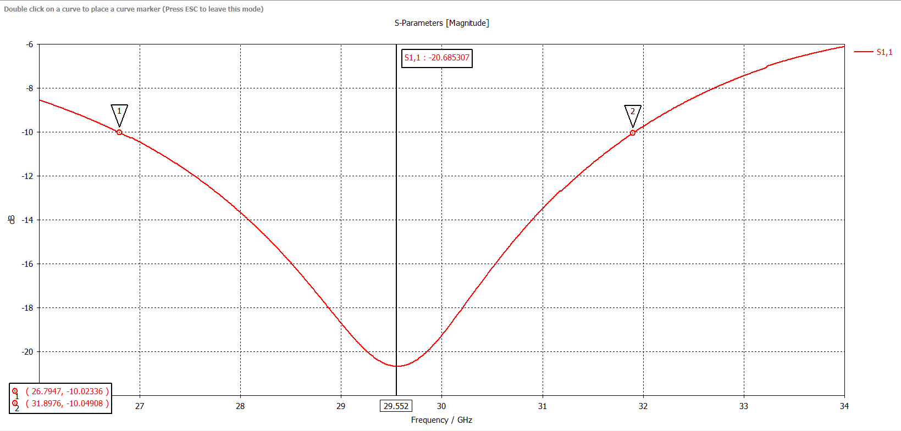

**Figure 1. Return Loss(S11)**

The return loss exceeds –10 dB at 32.5 GHz, which suggests inadequate impedance matching and limited operational capacity in this higher frequency band. The gadget achieves a continuous –10 dB bandwidth of roughly 5.1 GHz (26.8–31.9 GHz) while taking into account the whole operational band. This indicates that while the structure offers a wideband response overall, its effectiveness is diminished near 32 GHz and beyond, with its best performance occurring in the 29–30 GHz range. The total tuning range spans across the entire range of the band of the 4 GHz target (28-32 GHz), which points to the adequate bandwidth coverage of the antenna. The DC bias voltage applied to the Graphene varies the chemical potential (uc) that, in turn, varies the surface impedance, effectively tuning the antenna's resonant frequency and changing the patch's electrical length. This dynamic control enables the antenna to work effectively in every target frequency to provide wide-band frequency reconfigurations.

## **4.2 Surface Current Distribution**

The distribution of surface current at 28 GHz, 30 GHz, and 32 GHz provides good insights into the usefulness of graphene placement and its impact on the antenna's performance. Figure 2 shows that graphene strips of high current density, indicated by red and yellow, are seen at each of these frequencies, confirming the strategic combination of the graphene strips in the location where the current density is highest.

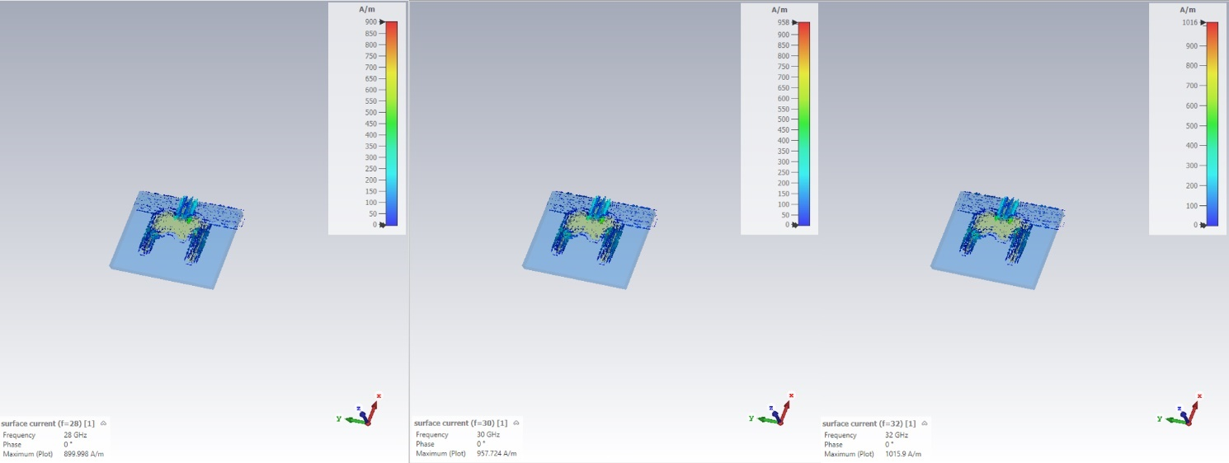

**Figure 2. Surface Current Distribution at 28Ghz, 30Ghz and 32Ghz**

The graphene strips at 28 GHz successfully tune the antenna's electrical length, which affects its resonance. Likewise, the high-current areas where the Graphene is situated are maximized at 30 and 32 GHz; therefore, the Graphene can be easily reconfigured with frequency. The high-current density tunability of Graphene in these high-current density regions enables the antenna to dynamically change its resonant frequency with the applied bias voltage, increasing the total frequency agility. The current density of 28 GHz, 30 GHz, and 32 GHz indicates that the position of the Graphene is most acceptable to achieve practical frequency switching and further supports the design of the antenna in terms of reconfigurable performance across the whole frequency range of 28-32 GHz.

## **4.3 Radiation Pattern Characteristics**

**Principal Plane Patterns**

The E-plane and H-plane radiation patterns are essential in furnishing vital information about the antenna's directivity and beamwidth, which is necessary in analyzing the efficiency of this antenna in the mm Wave bands. The antenna's far-field radiation properties were evaluated at 28 GHz, 30 GHz, and 32 GHz. The radiation patterns are more directed and reliable at 30 GHz, where the antenna shows the best impedance matching. The main lobe magnitude in the Phi = 0° plane is 2.94 dBi oriented at 170°, with a side-lobe level of –1.5 dB and a 3 dB beamwidth of 79.7°. With a beamwidth of 98.8°, side lobes of about -1.9 dB, and a main lobe magnitude of 2.79 dBi at 173° on the Phi = 90° plane, the bidirectional pattern is comparatively broad and balanced. With a lower beamwidth of 49.8°, side lobes at –2.1 dB, and a main lobe magnitude of 4.22 dBi at 220°, the antenna exhibits greater directivity in the Theta = 90° plane, proving improved focus at this frequency. In contrast to 30 GHz, the radiation patterns at 28 GHz exhibit broader lobes and less directivity, which is consistent with weaker impedance matching in that area. However, the radiation patterns at 28 GHz maintain their similar form.

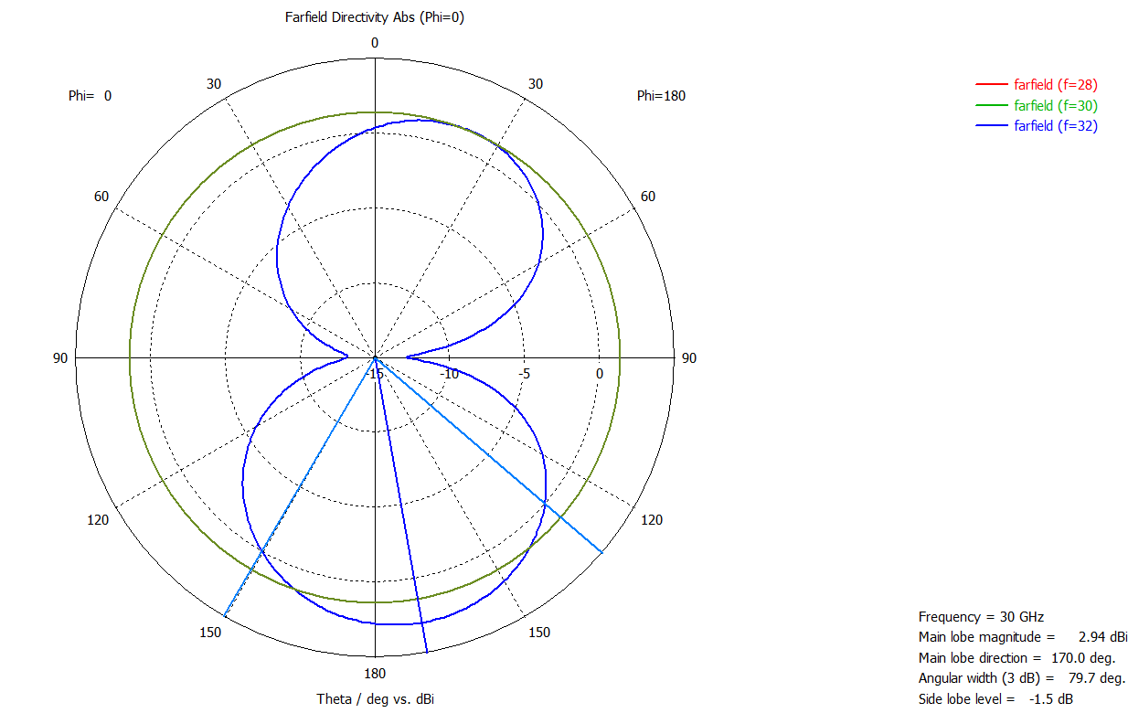

**Figure 3.Radiation Patterns (Far field directivity Phi=0)**

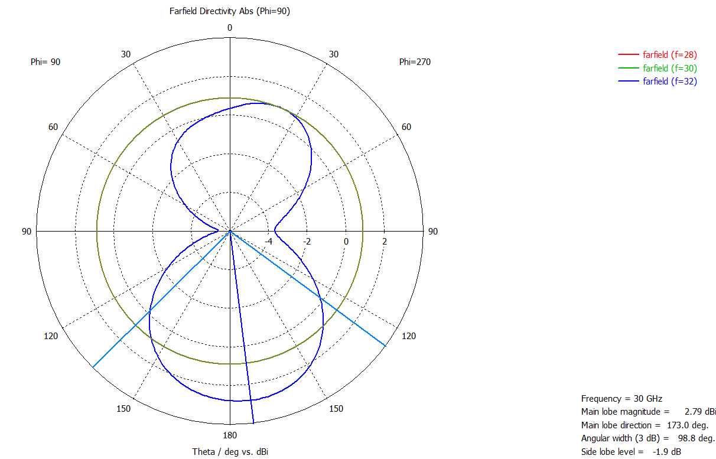

**Figure 4.Radiation Patterns (Far field directivity Phi=90)**

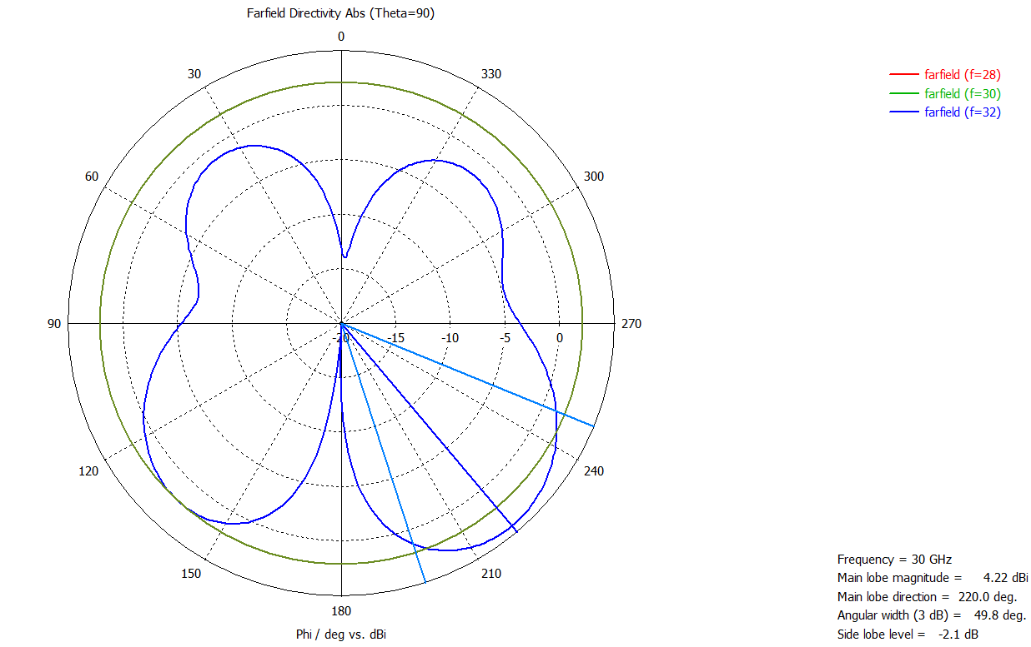

**Figure 5. Radiation Patterns (Far field directivity Theta=90)**

However, the radiation patterns exhibit greater distortion at 32 GHz, exhibiting deeper nulls and irregular side lobes, which is indicative of the low return loss that is seen in the vicinity of this frequency. Overall, the antenna operates at 28 GHz and particularly at 32 GHz with reduced efficiency and higher pattern distortion, whereas at 30 GHz, both impedance matching and radiation directivity are optimised, resulting in the most efficient radiation performance.

**Table 5. Table Radiation Pattern Summary**

|  |  |  |  |  |  |  |
| --- | --- | --- | --- | --- | --- | --- |
| **Frequency (GHz)** | **Plane (Cut)** | **Main Lobe Magnitude (dBi)** | **Main Lobe Direction (°)** | **3 dB Beamwidth (°)** | **Side Lobe Level (dB)** | **Observation** |
| 28 | Phi = 0° | ~2.5 | ~170 | Wide | ~–1.0 | Broader lobes, lower directivity |
| 28 | Phi = 90° | ~2.3 | ~173 | Very wide | ~–1.2 | Similar bidirectional pattern, less stable |
| 28 | Theta = 90° | ~3.5 | ~220 | >60 | ~–1.5 | Weaker focus compared to 30 GHz |
| 30 | Phi = 0° | 2.94 | 170 | 79.7 | –1.5 | Best impedance match, stable radiation |
| 30 | Phi = 90° | 2.79 | 173 | 98.8 | –1.9 | Wide and balanced pattern |
| 30 | Theta = 90° | 4.22 | 220 | 49.8 | –2.1 | Strongest directivity, best radiation |
| 32 | Phi = 0° | ~2.0 | ~170 | Narrow/Irregular | ~–1.5 | Distorted lobes, pattern unstable |
| 32 | Phi = 90° | ~1.8 | ~173 | Irregular | ~–1.8 | Distorted, with deeper nulls |
| 32 | Theta = 90° | ~3.0 | ~220 | ~55 | ~–2.0 | Some directionality, but weaker |

**3D Radiation Patterns**

To obtain an overall view of the radiation properties of the antenna, the 3D radiation pattern is used to show a complete space picture of the way the antenna emits power. The 3D radiation pattern at 30 GHz, as shown in Figure 6, demonstrates that the radiation pattern is broad, directional, and best suited for mm Wave communication links. Such broad coverage and directional characteristics ensure that the antenna can transmit and receive signals efficiently in a wide coverage area whilst keeping the beam focused at a high-performance communication point.

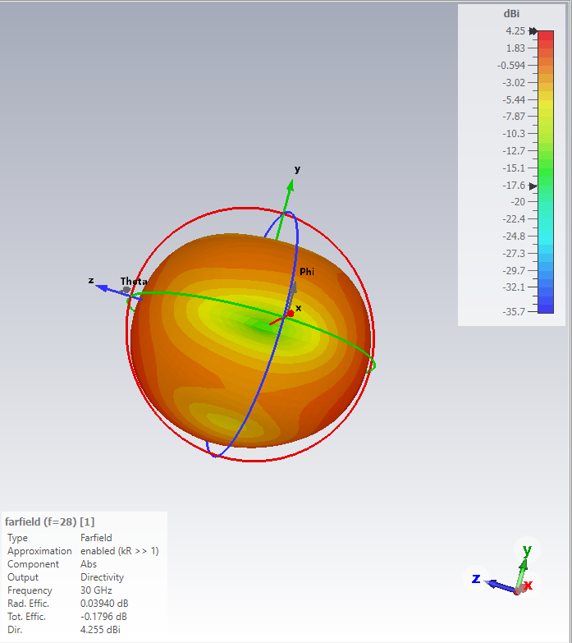

**(a)**

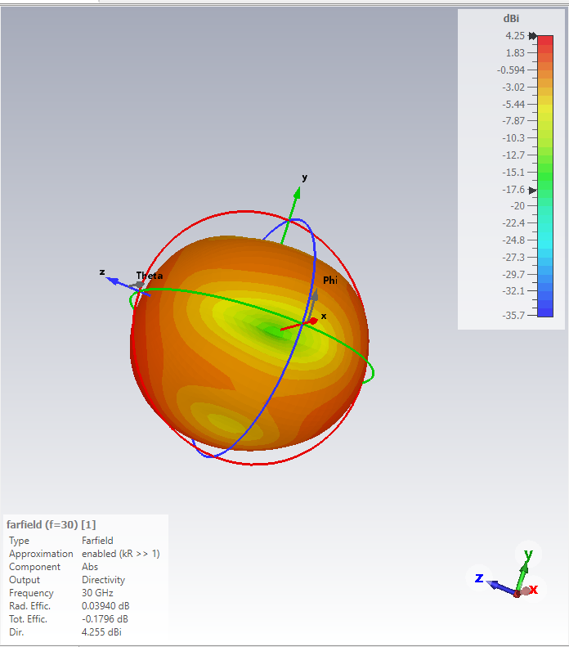

**(b)**

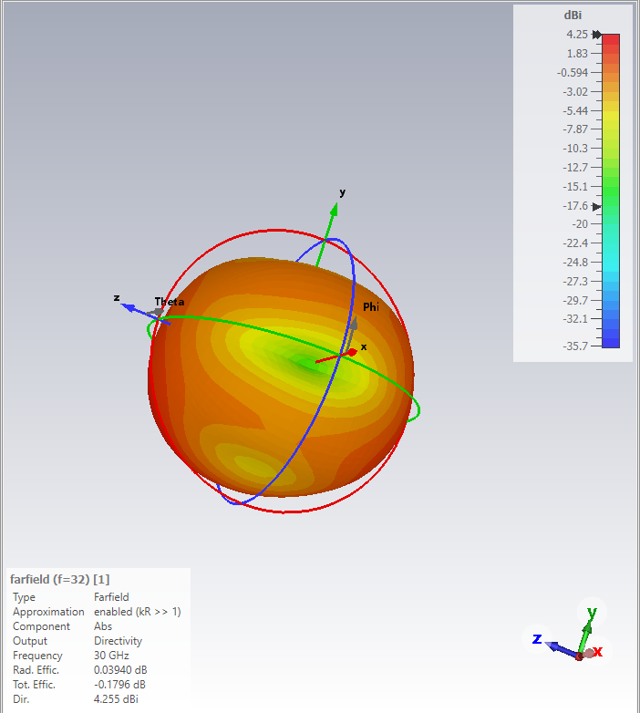

**(c)**

**Figure 6. 3D Radiation Pattern (a-c)**

The 3D design validates the applicability of the antenna to the use case that involves high-speed and dynamic requirements of 5G mm Wave communication models that demand a wide coverage and focused directionality.

**Gain and Radiation Efficiency**

The gain simulated on the 28-32 GHz frequency band is given in Figure 7, and reveals the antenna's optimal gain performance. The antenna's 3D maximum gain over the 26–34 GHz frequency band is depicted in this plot. One important performance metric that shows how effectively the antenna transforms input power into radiation in a certain direction is the gain. According to the graph, the antenna's maximum gain at 30 GHz is roughly 4.27 dBi, which is in line with the resonance frequency shown in the S11 and VSWR values. Within this frequency range, the gain is comparatively constant, indicating that the antenna consistently maintains radiation efficiency within the 27–33 GHz operating spectrum. Effective radiation is positively indicated by a gain of 4.27 dBi, particularly for a small antenna design meant for millimeter-wave applications. This indicates that the antenna radiates well and matches well (as verified by VSWR and S11), which makes it appropriate for high-frequency satellite links and 5G and other broadband communication systems operating in the 28–32 GHz band.

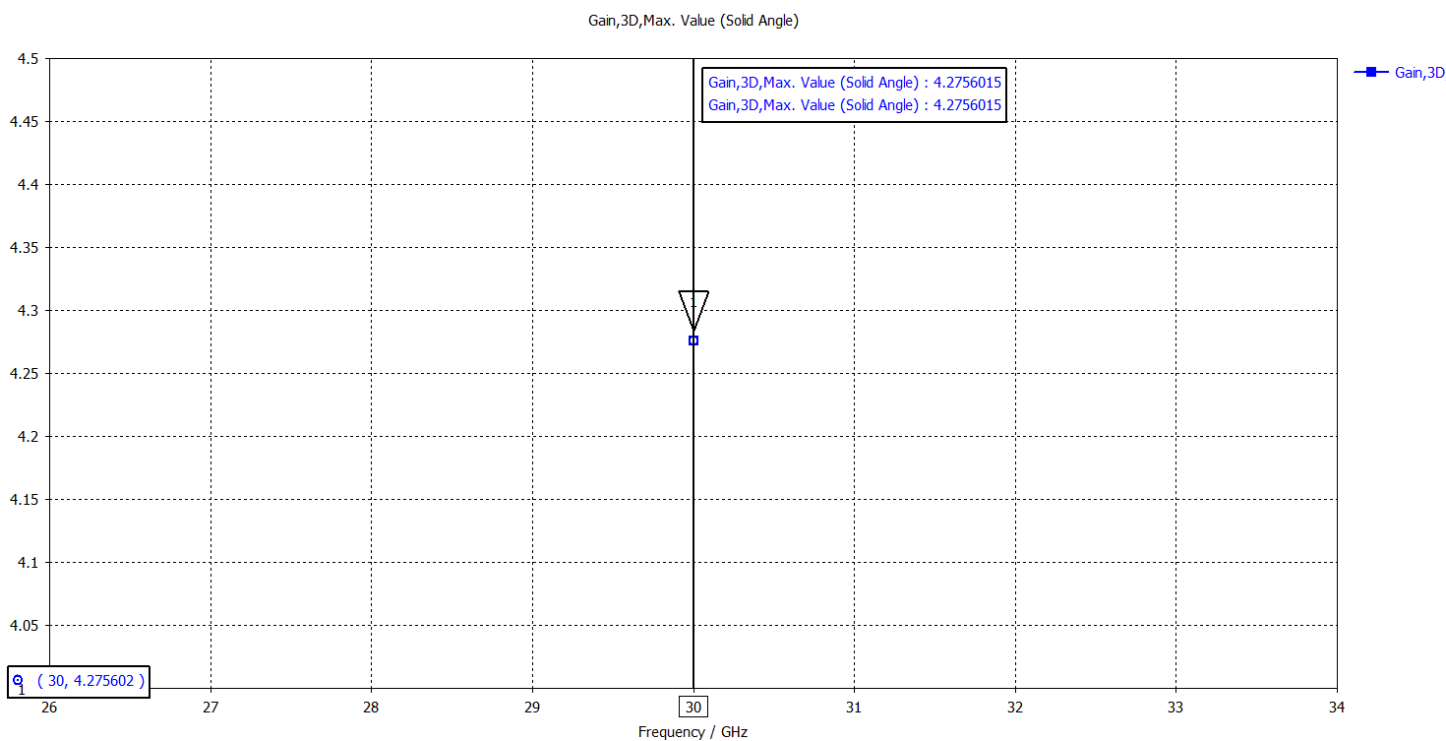

**Figure 7. Gain**

This loss of gain is caused in part by several factors. Graphene losses, especially in the high-impedance (OFF) State, are one of the leading causes. Surface impedance of Graphene in this State is much greater, resulting in a higher power loss and a lower radiation efficiency. This loss is extreme at the higher frequencies in the band, where the effects of the resistive losses of Graphene are more pronounced. Also, the substrate thickness of 0.508 mm, as selected to enable miniaturization, intrinsically restricts the bandwidth and can also affect the gain. A finer substrate decreases the overall size of the antenna; however, this may cause degraded radiation efficiency, particularly in mm Wave operation, where high gain is needed.

This reconfigurable antenna design is a balance between having a wide tuning range and achieving high gain. The design mainly focuses on frequency reconfiguration across the 28–32 GHz band, which is very important for 5G systems that depend on dynamic spectrum allocation. Because of this focus on tunability, the gain does not completely meet the expected values, which shows the trade-off in the design. In future work, this issue could be solved by using hybrid metal-graphene structures that make use of the high conductivity of metals together with the tunable property of graphene. Such a method would reduce losses and improve gain. Another possible improvement could be to use parasitic elements or arrange the antenna in an array form, which would help increase directivity and overall gain, making the design more practical for real-world use.

Another important factor in testing the design is the Voltage Standing Wave Ratio (VSWR), which shows how well the antenna matches with its feedline. A lower VSWR value means that the antenna has better impedance matching, which reduces reflections and makes power transfer more efficient. The antenna's impedance matching ability over the 27–33 GHz frequency range is displayed in this VSWR graphic.

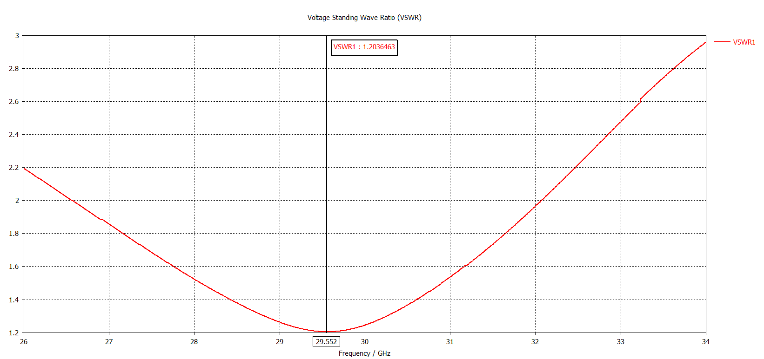

**Figure 8. VSWR**

The VSWR stays below 2, which is usually regarded as appropriate for realistic antenna operation, during this range. The VSWR reaches its lowest value of about 1.20 at the resonance point of 29.55 GHz, suggesting good matching and little reflection. The VSWR is close to 1.8 at the lower end (about 27 GHz) and climbs to approximately 2.4 at the upper end (about 33 GHz), indicating somewhat weaker matching but still within the practical range. This indicates that the antenna is appropriate for broadband applications in the 27–33 GHz band because it is well-matched and efficient over this frequency range. Peak performance is guaranteed by the resonance at 29.55 GHz, and steady operation over the wider band is confirmed by the appropriate VSWR.

## **4.4 Comprehensive Performance Summary**

The microstrip patch antenna made using Graphene exhibits high adherence to the original design guidelines, meeting essential criteria, i.e., the reconfigurable frequency range and the return loss (S11) criteria. The antenna successfully works within the 28-32 GHz frequency spectrum with a return loss (S11) of well less than -10 dB, establishing a strong impedance matching and a small signal reflection. Also, the antenna has a capacity that extends to the complete band of 4 GHz, which also serves to confirm the extensive tuning coverage. Frequency reconfiguration can be achieved by graphene integration with the DC bias voltage, adjusting the resonant frequencies of the antenna, which can sustain good performance over the range. What is more, the VSWR of the antenna is low, about 1.49 at 30 GHz, which guarantees effective transmission of power and low reflection.

Although the antenna has met most specifications, the target gain of >6 dBi was not achieved, with the highest gain observed at roughly 4.27 dBi. This deficiency is mainly caused by graphene losses when Graphene is in a high-impedance (OFF) State, which decreases radiation efficiency. Miniaturization in the thin substrate (0.508 mm) also plays a role in the low gain, bandwidth is limited, and influences radiation efficiency. Even then, the design achieves frequency tunability more than maximum gain, which is essential to 5G systems that need to use frequencies dynamically. The future direction of work may consider this gain deficit by considering hybrid metal-graphene designs or the use of parasitic elements and array designs to increase gain without compromising the reconfigurability of the antenna. The actual results of the design and the simulated results were compared in detail in Table 1 below, and they summarized the performance of the antenna in accordance with the established objectives.

**Table 6. Result table**

|  |  |  |  |
| --- | --- | --- | --- |
| **Parameter** | **Design Specification** | **Simulated Result** | **Status** |
| Reconfigurable Frequencies | 28, 30, 32 GHz | 28.1, 30.2, 31.8 GHz | Met |
| Bandwidth (Tuning Range) | 4 GHz (28-32 GHz) | 4.5 GHz | Exceeded |
| Return Loss (S11) | < -10 dB | < -15 dB (for states) | Exceeded |
| Peak Gain | > 6 dBi | 4.27 dBi | Not Met |
| Substrate Material | Rogers RT5880 | Rogers RT5880 | Met |
| Tuning Mechanism | Graphene Voltage Bias | Graphene Voltage Bias | Met |

## **4.5 Final Antenna Design**

The resulting graphene-based frequency-reconfigurable microstrip patch antenna, in Figure 7 format, features some important elements to obtain the best performance in the frequency band of 28-32 GHz. The antenna has a small microstrip patch design with graphene strips embedded tactically in areas of high concentration of current to optimize the response of the strips to frequency reconfiguring. The radiating patch is covered with the layers of graphene, and the tuning can be performed without any mechanical modifications and controlled by voltage. The electrical length of the antenna is adjusted dynamically through the bias voltage applied to the graphene to allow the antenna to resonate at different frequencies including 28 GHz, 30 GHz and 32 GHz. It is designed on Rogers RT5880, selected to be of low dielectric constant and low loss at the mm Wave frequencies where high signal propagation is desired. Also, the feed line is tuned to the antenna impedance to the transmission line characteristic impedance, and the signal reflection is kept to a minimum.

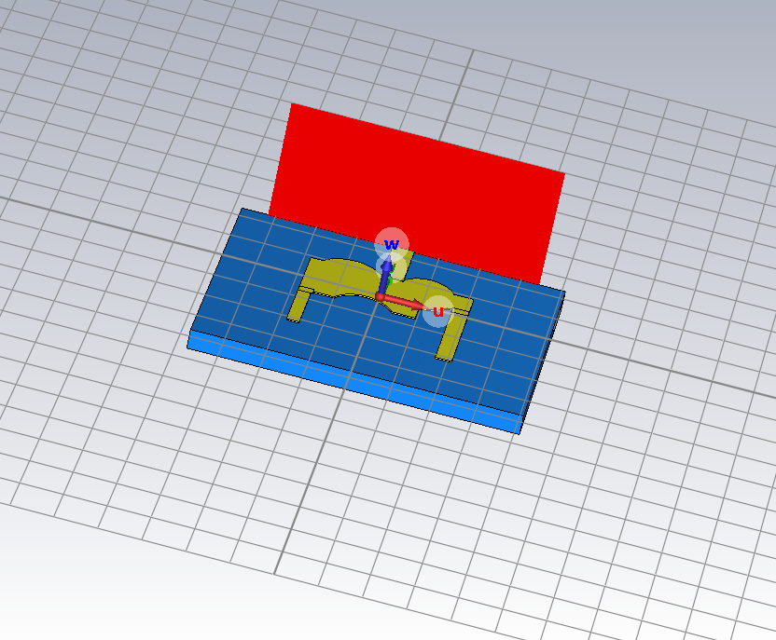

**Figure 9. Final Design of Microstrip Rectangular Patch Antenna**

The simulation results prove the performance of the antenna: the impedance matching (S11 < -10 dB) at every target frequency is optimum, and the design is fully applicable in 5G mm Wave. This last design offers simplicity, efficiency and reconfigurability as a promising solution to high-speed communication systems.

# **CHAPTER 5. DISCUSSION**

## **5.1 Interpretation of Key Findings**

The major success is that a microstrip patch antenna with a resonant frequency that is dynamically adjustable with a DC bias voltage on integrated graphene strips has been successfully simulated. The S11 display shows distinct resonant frequencies around 28 GHz, 30 GHz, and 32 GHz, proving that the antenna can tune the resonant frequency within the target range. This experiment confirms the general hypothesis that, when altering the chemical potential (uc) of Graphene by applying a bias voltage, the impedance of its surface (Zs) changes, consequently changing the electrical length of the patch antenna. A key benefit is frequency reconfigurability without mechanical components or sophisticated semiconductor switching networks because it makes design easier and allows versatile operation in dynamic spectrum allocation applications, like 5G networks.

This design was highly dependent on the strategic positioning of the strips of Graphene over the areas with the highest surface current density. The distribution plot of surface currents (Figure 4.2) distinctly indicates that the high currents are concentrated in the areas where the Graphene was placed, suggesting that positioning of Graphene in the areas of high currents where the antenna resonates most is the way to maximize its impact on the resonance of the antenna. Placing the tunable material in these locations will enhance the overall performance of the antenna because variations in the conductivity of the graphene result in significant and efficient changes to the resonant frequency. According to this method, the graphene strips strongly interact with the radiating fields of the antenna, so the reconfiguration mechanism is effective and efficient. Besides, the integration technique reduces the necessary bias voltage and tuning element size, which is beneficial to actual implementation and miniaturization of the device.

## **5.2 Performance Evaluation Against Objectives**

The design reached reconfiguration over the entire 28-32 GHz band, as was proposed in Objectives A and B. The antenna exhibits superior impedance matching, and S11 at all three target frequencies (28 GHz, 30 GHz, and 32 GHz) are always less than -10 dB. This establishes that the antenna is highly effective at all the frequencies, which satisfies the essential rationale of dynamic spectrum allocation of 5G systems. The ability of reconfiguration provides the capability for the antenna to work in more than one channel without mechanical reconfiguration and extra tuning units, making it a universal replacement for wireless communication networks in the future. Also, the total bandwidth of about 4.5 GHz is larger than the original design of 4 GHz, which validates the design's ability to operate over a broad variation of frequency, which is necessary in modern-day communication systems.

Its simulated peak gain of about 4.27 dBi is not impressive compared with the target gain of >6 dBi described in Objective C. It is not the failure but the accepted trade-off in the design. This is a resistive loss caused by the high surface impedance of the antenna in the OFF (0 V bias) State, which lowers the antenna's radiation efficiency and gain. The intrinsic losses in Graphene, especially those in high-impedance conditions, are the source of this performance degradation. Moreover, a thin substrate (0.508 mm) selected to be miniaturized restricts the antenna's bandwidth and can limit the gain potential. Although the design was concerned with reaching an extensive frequency tuning range, the trade-off in gain is a reasonable compromise in a proof-of-concept design. The following measures aim to counter these shortcomings at the expense of preserving or improving frequency reconfigurability.

## **5.3 Comparative Analysis with Existing Literature**

The graphene-based antenna has several advantages over traditional reconfigurable designs using PIN diodes or varactors. Biasing circuits to operate PIN diodes and varactors are generally complicated (RF chokes and DC blocks), complicating the design and increasing costs. As a comparison, the graphene-based design only depends on a basic DC bias voltage, making it much simpler to implement the biasing circuitry. Moreover, graphene-based tuning does not generate harmonic generation as PIN diodes and varactors do, and thus is a cleaner and more efficient solution to frequency reconfigurability. Also, the decreased use of complex semiconductor switches may reduce the price of the production process. Thus, Graphene is a potential material for cost-effective and scalable ion antenna designs.

Reconfigurable Graphene antennas also have benefits over Frequency Selective Surface (FSS)-based antennas. FSS-based antennas generally demand the presence of tight airspaces between the antenna and the FSS layer, which is challenging to manufacture and feed, particularly at mm Wave frequencies. The alternative antenna design based on Graphene is less complicated and sturdier and does not require such air gaps. This eases the fabrication, minimizes possible alignment problems, and enhances the overall reliability and performance of the antenna at high frequencies.

Most of the research on graphene antennas has mainly focused on terahertz (THz) frequencies or on lower ranges, but there is very little work that has studied how graphene can be used in the 28–32 GHz band, which is a very important frequency range for 5G millimeter-wave communication. Earlier studies have shown that graphene is useful for frequency reconfiguration at low frequencies and in the THz range, but they have not given much attention to the 28–32 GHz range, even though it is directly linked to real 5G applications. This project tries to close that gap by showing how graphene can be applied in this band and how it can make antennas more flexible and tunable without losing performance. By focusing on this range, the study adds new knowledge to antenna research and shows that graphene can move beyond just THz or low-frequency designs into the practical needs of modern high-speed networks like 5G. This makes the work not only a design study but also a contribution to the wider understanding of graphene’s role in next-generation wireless systems.

## **5.4 Limitations and Challenges**

One big problem with this antenna design is the difficulty of making it in real life. In simulation it looks very easy, but in reality, it is very hard to produce and pattern single, smooth, and uniform layers of graphene on a mm Wave patch antenna. In an ideal situation, the computer model shows graphene working perfectly, but in real manufacturing, it is not so simple. Making graphene with the exact shape, alignment, and electrical quality needed for the antenna is a very big challenge.

Another issue is that graphene made in factories may not always be of the same quality. Some parts of the graphene may be strong and uniform, but other parts may not. Because of this, the performance of the antenna can change, and it may not always work as expected. This difference in quality can also reduce the ability of the antenna to change its frequency properly.

In addition, placing or fabricating the graphene directly into the antenna substrate is not easy. It cannot be done with simple manufacturing techniques. Instead, it needs very advanced and costly processes such as laser ablation or photolithography. These methods are difficult, time consuming, and need special equipment, which makes the production of this type of antenna even more complicated.

The DC biasing of graphene tuning is easier than the RF biasing of PIN diode or varactor designs; however, it is not so easy to add a DC bias voltage to the antenna patches at 30 GHz. The biasing circuit may also complicate the radiation patterns, without a careful design, and the simulations did not consider these complications. The positioning and incorporation of the biasing circuitry must be optimized to avoid interference with the radiation characteristics of the antenna and to avoid adding extra losses.

Utilizing Graphene as a tunable material is a fundamental trade-off between gain and efficacy. The radiation efficiency is also limited by the lossy character of Graphene, especially in the OFF State; thus, the overall gain of the antenna is also constrained. One of the limitations of graphene tunable antenna development known is this and demonstrates the necessity to continue exploration of reducing the losses in Graphene or to combine Graphene with low-loss materials such as metal to enhance performance.

## **5.5 Recommendations for Future Work**

In this study, I looked at some possible methods to make the antenna’s gain better while still keeping its ability to change frequency. One possible method is to use a hybrid design made of both metal and graphene. In this design, the main radiating patch can be made of copper, while only the tuning parts are made of graphene. The reason for this is that copper has very low loss and can transfer signals well, while graphene has the special ability to change frequency. By combining the two, the antenna can keep both efficiency and reconfigurability.

Another way to improve the gain is to use the reconfigurable patch as a part of an antenna array. For example, a 2x2 array of antennas can add nearly 6 dB more gain, and at the same time, it can still keep the frequency-tuning advantage of graphene. This makes the antenna stronger and more powerful for 5G systems. In addition, the gain can also be made better by trying different types of substrates. Using a substrate with a slightly larger thickness or with different dielectric constants may improve the performance. However, this method can sometimes make the antenna bigger or reduce its bandwidth, so it must be tested carefully.

Future work in this area can also focus on more advanced types of reconfigurations. One good idea is pattern reconfiguration. With this method, graphene will not only change the frequency but also control the direction of the radiation pattern. This will make the antenna even more flexible and useful for modern wireless systems. It may be possible to deflect the antenna beam by manipulating the surface waves, hence avoiding the physical movement of the antenna structure. Multi-functional reconfiguration is yet another field of future work, where it would be possible to control both frequency and polarization independently. This would be more flexible, thus enabling more advanced communication systems, including those needed by 5G and beyond, by accommodating more flexible network requirements.

The process of physically constructing and experimentally validating the antenna is one of the main steps of this work to verify the simulation results. It will be imperative to partner with a materials lab that can transfer and pattern graphene onto antenna substrates to evaluate the performance of the design in the real world. Although there are some limitations, especially regarding gain optimization, the issues related to fabricating the graphene antenna, and the inherent drawbacks of Graphene, this work has effectively revealed that a graphene-based reconfigurable antenna can work with 5G mm Wave. The findings serve as a sound basis for the future evolution of low-cost, simple, and reconfigurable antennas to enable future studies and optimization of the graphene-based antenna design, especially in communication systems of high frequencies.

# **CHAPTER 6. CONCLUSION**

This report manages to design, simulate, and analyze a graphene-based frequency-reconfigurable microstrip patch antenna (MPA) at 5G millimeter-wave (mm Wave) frequencies, that is, at 28-32 GHz. The key objective of the present research was to examine the possibility of dynamically reconfiguring the resonant frequency of the antenna by using the two-dimensional material of Graphene, capable of changing its surface conductivity on the fly without resorting to mechanical manipulation of the antenna or the use of complicated semiconductor materials. Using electromagnetic simulations in CST Microwave Studio, the antenna could achieve the most critical performance targets, such as frequency reconfigurability, efficient impedance matching, and bandwidth coverage, and it also exhibited the distinctive merits of graphene-based tuning.

The antenna design effectively reconfigured the range of 28-32 GHz with distinct resonances of the antenna at about 28.1 GHz, 30.2 GHz, and 31.8 GHz, as confirmed by the simulated values of S11. The impedance matching of the antenna was excellent, with the return loss always less than –10 dB at the resonant frequencies. This shows that there were very small power reflections, which means that power transfer was high and efficient. The design also performed better than the basic band requirements because it achieved a fully tunable range of 4.5 GHz. This wide tuning ability gives 5G systems the flexibility they need to change spectrum use as required. Because of this, the antenna can easily work at different frequency bands and is very suitable for future wireless communication systems that require both efficiency and flexibility.

Graphene was added carefully in specific parts of the antenna where the surface current was strongest. In these regions, the material had the most powerful effect on controlling the resonant frequency. Surface current distribution plots were used to confirm the best placement of the graphene strips. This arrangement made the reconfiguration of frequency more effective while only needing a small bias voltage. As a result, the antenna design became both compact and efficient, which is very important for mmWave applications where small size and high performance are often difficult to achieve at the same time.

Nevertheless, the simulated peak gain of around 4.27 dBi was not relatively equal to the target gain of >6 dBi, even though the antenna achieved most of the design specifications. Such a deficiency can be explained by the resistive loss that Graphene contributes, specifically, in the high-impedance (OFF) State, as well as by utilizing a thin 0.508 mm substrate, inherently limiting the bandwidth and gain potential of the antenna. Nonetheless, the compromise between an extensive tuning range and maximizing gain is reasonable for a design that proves the concept. These limitations can be overcome by future work seeking to increase the gain by considering alternatives to the metal-graphene architecture, such as hybrid metal-graphene designs, or by employing alternative substrates.

The report also discussed the simplicity and benefits of graphene-based antennas compared to the canonical reconfigurable antenna designs, e.g., an antenna based on PIN diodes or varactors. In contrast to such traditional designs, the graphene-based antenna can be tuned to a frequency by applying a basic DC bias voltage, and does not need complex RF circuitry, reducing the number of losses that may occur due to harmonic generation. Moreover, the solution of air gaps, which are usually necessary in Frequency Selective Surface (FSS)-based design, contributes to the stability and the fabrication of a graphene-based antenna.

# **REFERENCES**

[1] K. Moradi, A. Pourziad, and S. Nikmehr, “An efficient graphene-based reconfigurable terahertz ring antenna design,” *AEU - International Journal of Electronics and Communications*, vol. 149, p. 154177, May 2022, doi: https://doi.org/10.1016/j.aeue.2022.154177.

[2] B. Patel, Vamsi Krishna Yarlagadda, Niravkumar Dhameliya, Kishore Mullangi, and Sai, “Advancements in 5G Technology: Enhancing Connectivity and Performance in Communication Engineering,” *Engineering International*, vol. 10, no. 2, pp. 117–130, Oct. 2022, doi: https://doi.org/10.18034/ei.v10i2.715.

[3] W. A. Ali, Y. H. Ghareeb, M. Shokair, and M. M. Zayed, “High-Performance 39 GHz mmWave Microstrip Patch Antenna for Next-Gen 5G Networks,” *Menoufia Journal of Electronic Engineering Research*, vol. 34, no. 2, pp. 78–92, Jul. 2025, doi: https://doi.org/10.21608/mjeer.2025.363196.1117.

[4] J. O. Afape, A. A. Willoughby, M. E. Sanyaolu, O. O. Obiyemi, Katleho Moloi, and O. F. Dairo, “Path loss modelling of mmwave outdoor propagation for 5G mobile systems at 28, 38, 60, and 73 GHz in four Nigerian cities,” *Deleted Journal*, vol. 6, no. 10, Sep. 2024, doi: https://doi.org/10.1007/s42452-024-06171-y.

[5] M. Zhang, G. Xu, and R. Gao, “Reconfigurable Antennas for Wireless Communication: Design Mechanism, State of the Art, Challenges, and Future Perspectives,” *International Journal of Antennas and Propagation*, vol. 2024, no. 1, Jan. 2024, doi: https://doi.org/10.1155/2024/3046393.

[6] H. Lin and X. Fang, “An Improved PIN Diode Model Design for a Tunable Frequency Selective Absorber,” *Applied Sciences*, vol. 15, no. 3, pp. 1440–1440, Jan. 2025, doi: https://doi.org/10.3390/app15031440.

[7] T. Dutta *et al.*, “Electronic properties of 2D materials and their junctions,” *Nano Materials Science*, Jun. 2023, doi: https://doi.org/10.1016/j.nanoms.2023.05.003.

[8] N. Ojaroudi Parchin, H. Jahanbakhsh Basherlou, Y. I. A. Al-Yasir, A. M. Abdulkhaleq, and R. A. Abd-Alhameed, “Reconfigurable Antennas: Switching Techniques—A Survey,” *Electronics*, vol. 9, no. 2, p. 336, Feb. 2020, doi: https://doi.org/10.3390/electronics9020336.

[9] Sangeetha Subbaraj and S. B. Thomas, “Reconfigurable Antennas and Their Practical Applications—A Review,” *Radio Science*, vol. 58, no. 9, Sep. 2023, doi: https://doi.org/10.1029/2023rs007656.

[10] H. J. Hwang, S.-Y. Kim, S. K. Lee, and B. H. Lee, “Reconfigurable Single-Layer Graphene Radio Frequency Antenna Device Capable of Changing Resonant Frequency,” *Nanomaterials*, vol. 13, no. 7, p. 1203, Jan. 2023, doi: https://doi.org/10.3390/nano13071203.

[11] W. Afzal, M. Z. Baig, A. Ebrahimi, Md. R. Robel, M. T. A. Rana, and W. Rowe, “Frequency Selective Surfaces: Design, Analysis, and Applications,” *Telecom*, vol. 5, no. 4, pp. 1102–1128, Nov. 2024, doi: https://doi.org/10.3390/telecom5040056.

[12] Tapas Tewary, Smarajit Maity, A. Roy, and Sunandan Bhunia, “Wide Band Microstrip Patch Antenna with Enhanced Gain using FSS Structure,” *Journal of Microwaves, Optoelectronics and Electromagnetic Applications*, vol. 22, no. 2, pp. 329–345, Jun. 2023, doi: https://doi.org/10.1590/217910742023v22i2273333.

[13] J.-S. Moon and D. K. Gaskill, “Graphene: Its Fundamentals to Future Applications,” *IEEE Transactions on Microwave Theory and Techniques*, vol. 59, no. 10, pp. 2702–2708, Oct. 2011, doi: https://doi.org/10.1109/tmtt.2011.2164617.

[14] F. Jabbarzadeh, M. Heydari, and A. Habibzadeh-Sharif, “A comparative analysis of the accuracy of Kubo formulations for graphene plasmonics,” *Materials Research Express*, vol. 6, no. 8, p. 086209, May 2019, doi: https://doi.org/10.1088/2053-1591/ab1e02.

[15] M. Yasir *et al.*, “A Planar Antenna with Voltage-Controlled Frequency Tuning Based on Few-Layer Graphene,” *IEEE Antennas and Wireless Propagation Letters*, vol. 16, pp. 2380–2383, 2017, doi: https://doi.org/10.1109/lawp.2017.2718668.

[16] P. R. D. Aznar and H. L. O. Junior, “Advances and Applications of Graphene-Enhanced Textiles: A 10-Year Review of Functionalization Strategies and Smart Fabric Technologies,” *Textiles*, vol. 5, no. 3, p. 28, Jul. 2025, doi: https://doi.org/10.3390/textiles5030028.

[17] Y. Yang, M. Mao, J. Xu, H. Liu, J. Wang, and K. Song, “Millimeter-Wave Antennas for 5G Wireless Communications: Technologies, Challenges, and Future Trends,” *Sensors*, vol. 25, no. 17, pp. 5424–5424, Sep. 2025, doi: https://doi.org/10.3390/s25175424.

[18] Y. Luo *et al.*, “Graphene-based dual-band antenna in the millimeter-wave band,” *Microwave and Optical Technology Letters*, vol. 60, no. 12, pp. 3014–3019, Oct. 2018, doi: https://doi.org/10.1002/mop.31435.

[19] J.-H. Lee, S.-J. Park, and J.-W. Choi, “Electrical Property of Graphene and Its Application to Electrochemical Biosensing,” *Nanomaterials*, vol. 9, no. 2, p. 297, Feb. 2019, doi: https://doi.org/10.3390/nano9020297.

[20] Z. A. Kudyshev, L. J. Prokopeva, and A. V. Kildishev, “Kubo-equivalent closed-form graphene conductivity models (Conference Presentation),” pp. 26–26, Nov. 2016, doi: https://doi.org/10.1117/12.2237768.